Ex. No. 1 | JAVA LOOP
YouTube Link
Date of Exercise | DD.MM.YYYY

Aim
To understand and practically implement different types of looping constructs in Java programming, including `for`, `while`, and `do-while` loops.

Description
Loops in Java are control flow statements that allow a block of code to be executed repeatedly based on a given boolean condition. They are essential for automating repetitive tasks, iterating over collections, and processing data efficiently. Java provides three primary looping constructs: the `for` loop, suitable when the number of iterations is known; the `while` loop, which continues to execute as long as a specified condition remains true; and the `do-while` loop, which guarantees at least one execution of its body before checking the condition. These loops enable developers to write concise and powerful code for tasks such as array traversal, menu-driven applications, and event handling.

Program
public class LoopDemonstration {
public static void main(String[] args) {
System.out.println("--- Java Loop Demonstration ---");
// 1. For Loop: Executes a block of code a specific number of times.
// Used when the number of iterations is known.
System.out.println("\n1. For Loop (Counting from 1 to 5):");
for (int i = 1; i <= 5; i++) {
System.out.println(" Count: " + i);
}
// 2. While Loop: Executes a block of code as long as a condition is true.
// Used when the number of iterations is not known beforehand.
System.out.println("\n2. While Loop (Counting down from 3):");
int j = 3;
while (j > 0) {
System.out.println(" Countdown: " + j);
j--;
}
// 3. Do-While Loop: Executes a block of code at least once,
// then repeats as long as a condition is true.
System.out.println("\n3. Do-While Loop (Printing once, then checking condition):");
int k = 1;
do {
System.out.println(" Execution " + k);
k++;
} while (k <= 0); // Condition is false, loop runs only once.
System.out.println("\n--- Loop Demonstration Complete ---");
}
}

Output Screenshot
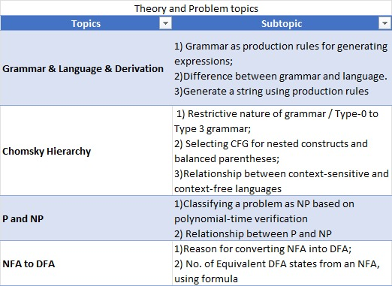

Result
The experiment successfully demonstrated the implementation and behavior of `for`, `while`, and `do-while` loops in Java. The objective of understanding and practically applying these looping constructs was achieved, illustrating their distinct use cases for controlled iteration and conditional repetition based on different requirements.

